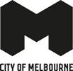

Elizabeth Street Catchment Integrated Water Cycle Management Plan 2015

Disclaimer
This report is provided for information and it does not purport to be complete. While care has been taken to ensure the content in the report is accurate, we cannot guarantee is without flaw of any kind. There may be errors and omissions or it may not be wholly appropriate for your particular purposes. In addition, the publication is a snapshot in time based on historic information which is liable to change. The City of Melbourne accepts no responsibility and disclaims all liability for any error, loss or other consequence which may arise from you relying on any information contained in this report.
To find out how you can participate in the decision-making process for City of Melbourne’s current and future initiatives, visit melbourne.vic.gov.au/getinvolved
Contents
Overview 3
Targets 4
What’s in the Plan? 5
Historical context 7
Elizabeth Street Catchment Map 8
Key challenges 9
Climate change 9
Flash flooding 9
Heatwaves 9
Population growth, urbanisation and open space 9
Maintaining our Urban Forest 10
Integrated water cycle management in a city 11
Progress to date 12
Case studies 13
Royal Exhibition Building and Melbourne Museum stormwater harvesting tanks – 2011 13
Queen Victoria Market stormwater harvesting tanks - 2006 13
The University of Melbourne Economics Building blackwater recycling project - 2010 14
Little Bourke Street rain garden tree pits 14
Collins Street permeable paving project 15
Targets in detail 15
What’s needed? 17
Drainage Capacity. 17
Drainage capacity increase 18
Water use 19
Sealed soil 20
Water Quality 20
Open space and canopy cover 21
Key opportunities 22
Action Plan 24

Overview
The Elizabeth Street Catchment Integrated Water Cycle Management Plan is a strategy for sustainable water management within the 308-hectare Elizabeth Street Catchment that will guide our actions for the next 15 years to 2030.
The Catchment sits entirely within the municipality of Melbourne. It starts at College Crescent in Carlton and finishes where the Elizabeth Street drain joins the Yarra River below Flinders Street Station.
The Elizabeth Street Catchment is categorised by Melbourne Water as being at Extreme Flood Risk – the highest level. Our Plan includes an approach to reduce this flood risk. It also includes ways to use alternative water sources to irrigate existing and future parks and open spaces.
As one of the biggest water users in the municipality and as the manager of stormwater on roads, parks and open space within the city, the City of Melbourne has a leadership role to play in water cycle management.
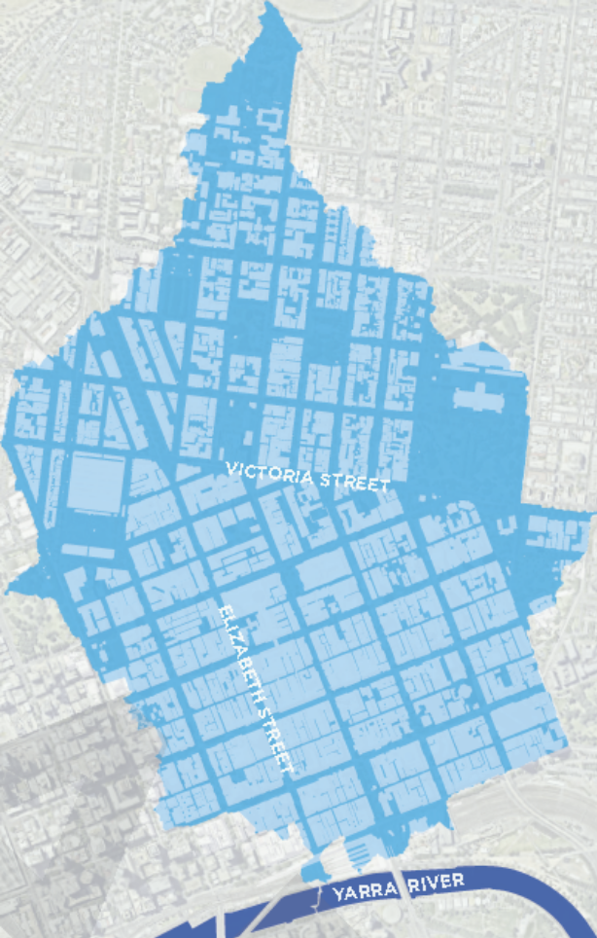
Caption: The Elizabeth Street Catchment
The Plan involves all the elements of the water cycle that the City of Melbourne can influence – water consumption, rainwater, stormwater, wastewater and groundwater management.
It is part of a much bigger program of work we are undertaking for Melbourne to become one of the world’s most sustainable cities. We know that a successful future depends on understanding the risks that climate change poses, reducing our impact, and becoming more resilient.
The City of Melbourne practices integrated water cycle management. This is the coordinated management of all components of the water cycle including water consumption, rainwater, stormwater, wastewater and groundwater, to secure a range of benefits for the wider catchment
Objectives
- To reduce the Catchment’s Melbourne Water Flood Risk rating from Extreme to High
- To increase open space, soil moisture and areas of unsealed soil in Elizabeth Street Catchment
- To mimic the natural water cycle by retaining more rainwater in the upper section of the catchment and reducing stormwater runoff
- To improve the health of existing vegetation through irrigation from alternative water sources

Targets
To meet our objectives, we will strive to achieve the targets outlined in the table. These targets have previously been set in the City of Melbourne’s Total Watermark – City as a Catchment Update 2014, our Urban Forest Strategy and our Open Space Strategy.
Flooding
1:20 Average Recurrence Interval (ARI) (or equivalent) flow capacity of all council drains within the catchment.
Alternative water use
2018 targets
• 8% of all municipal water use sourced from alternative water sources
• 30% of all council water use sourced from alternative water sources.
2030 targets
• 20% all municipal water use sourced from alternative water sources
• 50% of all council water use sourced from alternative water sources.
Current Level within the Catchment: Council 13% (5.5ML), Municipal 1% (75ML)
Unsealed soil
40% of the Elizabeth Street Catchment’s soil surface is unsealed by 2030 (baseline year 2014).
Current Level within the Catchment: 17% unsealed soil
Water quality
2018 target
20% reduction in Total Nitrogen contributed to the waterways from the municipality of Melbourne’s catchment (baseline year 2000).
2030 target
30% reduction in Total Nitrogen contributed to the waterways from the municipality of Melbourne’s catchment (baseline year 2000).
Current Level within the Catchment: 2% reduction in Total Nitrogen
Open space
Increase the provision of open space in the Catchment in line with the Open Space Strategy and the City North Structure Plan.
Canopy cover
Increase canopy cover to 40% on public land across the Catchment by 2040.
Current Level within the Catchment: 21.8% of the public land has a canopy cover.
What is sealed soil?
Sealed soil refers to paving, roads and buildings covering the soil, preventing air and water from getting in. Unsealed, or permeable, soil includes soil that has no asphalt, concrete or paving on it, whether it be bare earth, soil covered by grass or other vegetation. Permeable paving is an approximate of unsealed soil, as it allows water and air to permeate through paved surfaces, including road surfaces. Green roofs are one of the methods used to offset the effect of creating a sealed surface. Although water cannot reach the ground under a building, a new layer of soil is being provided on the rooftop that can hold and filter water.
What are alternative water sources?
Alternative water sources are non-drinking water sources. This can include reusing rainwater, stormwater, or recycled wastewater - sewerage, blackwater or greywater.

What’s in the Plan?
The Plan outlines a suite of projects and initiatives to be implemented over the next five years. These actions will enable us to reduce flooding, mimic the natural water cycle, increase the area of unsealed soil, open space and soil moisture and to improve vegetation quality.
It outlines our targets in detail and the quantum of work needed to meet them.
The Plan also includes case studies of successful blackwater recycling, rainwater and stormwater harvesting projects that have been implemented over the past decade in the Catchment.
During the implementation of this Plan we aim to:
- Improve the health and wellbeing of the community
- Increase the resilience of the public and private realm through cooling and flood mitigation
- Decrease water and air pollution through increasing green space
- Improve the microclimate to reduce the urban heat island and increase resilience to climate change.
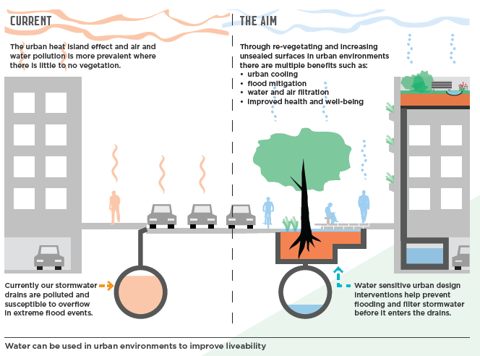
Caption: Water can be used in urban environments to improve liveability.

Whose water is it to manage?
The Elizabeth Street Catchment is highly urbanised with a variety of land uses, owners and stakeholders. This complexity is challenging, but also provides opportunity for collaboration across the community to meet our objectives of reducing flooding, re-naturalising the Catchment, increasing open space, permeability and soil moisture and improving vegetation quality.
The City of Melbourne has a key role to play in the Elizabeth Street Catchment. We are one of the biggest water users in the municipality. A large portion of this water is used for irrigation of our public parks, gardens and vegetation. We are responsible for the local drainage network, stormwater and implementing alternative water supply projects. The City of Melbourne is also the planning authority for building applications involving less than 25,000m² floor area, so we can regulate how water is managed in new buildings on private property.
The Victorian Government’s Department of Environment, Land, Water and Planning is responsible for providing direction within the water sector, across both metropolitan Melbourne and Victoria. Its role includes increasing collaboration between the different agencies that manage our catchments and waterways including planning and transport bodies.
The successful delivery of this Plan will depend on maintaining strong partnerships with the Department of Environment, Land, Water and Planning (DELWP), Melbourne Water as the main drain manager in the catchment, and City West Water as the water retailer. We will also work with the University of Melbourne, RMIT, the broader community and the business sector to achieve our objectives.
One key action will be to establish an Elizabeth Street Catchment reference group with representation from a number of these organisations to coordinate activities.
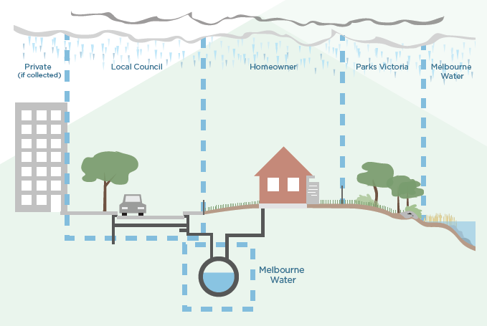
Water is managed by a range of entities.

Historical context
The area now known as Elizabeth Street was originally a creek that fed into the Yarra River. “Williams Creek”, as it was originally called, was piped underground when the street was built, but the area is still a natural low point and drainage line. As such, it has always been an area susceptible to flooding.

William Westgarth who was the first member of Melbourne City Council and the founder and first president of the Melbourne Chamber of Commerce, stated in his personal reflections:
“Melbourne missed a great chance in filling up with a street (Elizabeth) this troublesome, and, as a street, unhealthy hollow. Dr Howitt used to tell me he never could cure a patient, resident there, who had become seriously unwell. A reservation of the natural grass and gum-trees between Queen and Swanston streets would have redeemed Melbourne up to the first rank of urban scenic effect, and the riotous Williams (Creek) might, with entire usefulness, have subsided into a succession of ornamental lakes and fish ponds.” - William Westgarth, 1842
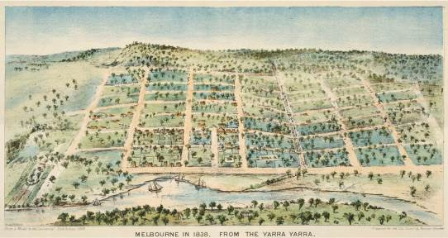
Elizabeth Street
Caption: Melbourne in 1838 from the Yarra Yarra.

Significant flood history in Melbourne
1863 | Major flood puts Port Melbourne under water. Thousands left homeless across the city, and one man drowned
1882 | Elizabeth St in flood
1891 | The great flood causes the Yarra River to swell to 305metres in width. Described as the worse flood in history it leaves thousands homeless and causes at least one death
Nov-Dec 1934 | Torrential rainfall of up to 350mm. Yarra River becomes a ranging torrent. Extension damage with 35 dead, 250 injured and 3000 homeless
3 Dec 1954 | Record wet day, homes evacuated, flooding of Flinders St, Swanston St and major events cancelled
Feb 1972 | Elizabeth St is flooded after a massive downpour of rain, with dramatic pictures of cars floating and underwater in the central city
6 March 2010 | Large hail, flash flooding and high winds, cause widespread damage across western and central Victoria, all modes of transportation in Melbourne stopped. Flinders, Spencer and Elizabeth streets were spectacularly flash flooded
4 Feb 2011 | Severe rainstorm cause flash flooding in parts of Melbourne
31 May 2013 | Melbourne faced heavy rain and thunderstorms

Elizabeth Street Catchment Map
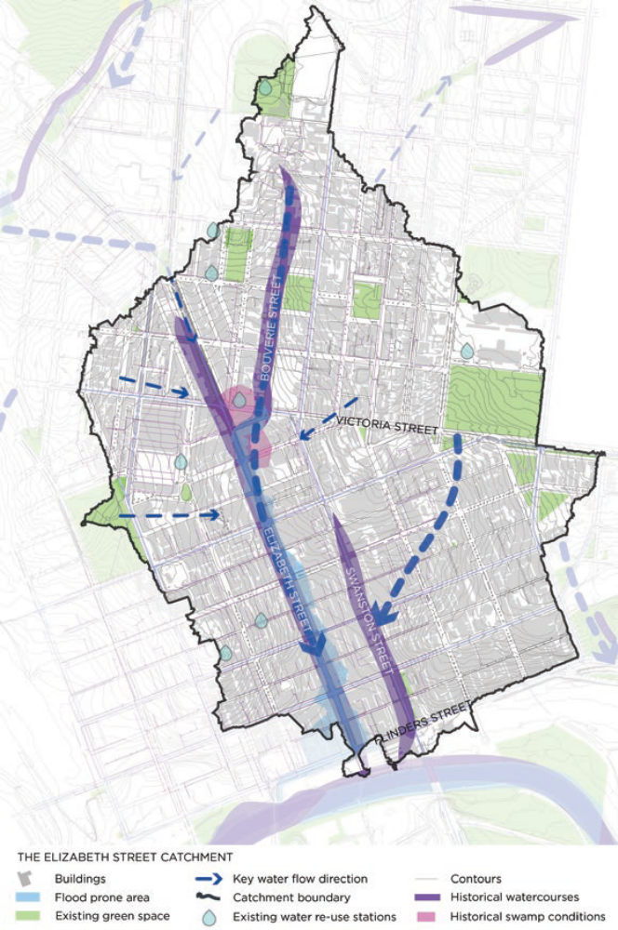
Caption: The Elizabeth Street Catchment

Key challenges
We face several major challenges in meeting our objectives of reducing flooding, increasing open space, soil moisture and unsealed soil and improving vegetation quality in the Elizabeth Street Catchment.

Climate change
Without significant international movement to decrease emissions in the next few years we are predicted to experience a temperature increase of between 2°C – 6.2°C by 2100, which exceeds what is now commonly accepted as the threshold for dangerous climate change, a 2°C increase.

By 2030 Melbourne is predicted to be significantly affected by warmer temperatures and heatwaves, lower winter and spring rainfall, intense storm events and flash flooding. By 2070 we are predicted to be experiencing more than double the number of heatwaves, a more than 10 per cent reduction in rainfall and a significant increase in extreme storm events. These climate changes will affect the Elizabeth Street Catchment as well as the broader municipality.

Flash flooding
Rapid climate change is resulting in less but more intense bursts of rainfall, leading to an increase in flash flooding. Elizabeth Street Catchment is a natural low point and drainage line and is subject to inundation. The Catchment includes both the Elizabeth Street drainage network and the Swanston Street drainage network. This is because when the Swanston Street drain is over capacity and water is flowing along the roads, water from Swanston Street runs downhill to Elizabeth Street.
As a busy inner city street, thousands of people are affected when it floods. Flooding within this catchment affects the trams that use Elizabeth Street along with other vehicles. Pedestrians are also affected by floodwater making footpaths dangerous and sometimes impassable. The properties lining Elizabeth Street are also subject to inundation.
Small flooding events can cause damage to property and transport disruptions. Major flooding can result in damage to businesses and residences, stranding of residents and employees, injuries and fatalities. It can also cause environmental damage due to erosion, sewerage overflows and contamination of waterways.
The impacts of flooding have huge economic costs. In the late 2000s, the average direct annual damage cost of all forms of flooding across Victoria was estimated to be approximately $450 million.

Heatwaves
The frequency and intensity of heatwaves is expected to increase, and with it the economic impacts of such events on businesses. The extreme heat experienced in Melbourne between 14 and 17 January in 2013 is estimated to have cost businesses in the municipality $37 million in lost revenue. The risk of extreme heat to human health is also a serious concern.
During the Black Saturday fires in 2009, the deaths of the 173 people directly from the fires were widely reported. Less well known however, were the 374 deaths in Victoria that resulted from the five-day heat wave preceding Black Saturday. Due to the Catchment’s highly urbanised nature, combined with the high daily visitation, heatwave effects will be particularly noticeable in the Elizabeth Street Catchment.

Population growth, urbanisation and open space
By 2030, the municipality of Melbourne’s current population of approximately 105,000 (as at 2012) is predicted to more than double. Our worker and visitor populations are also increasing rapidly, with 1.2 million daily visitors projected by 2030, up from 800,000 daily in 2013.

Demographically the city has also changed. An apartment building boom has meant that 93 per cent of new homes built between 2006 and 2012 were apartments. Our 2012 City North Structure Plan states that by 2040, there will be more than 10,000 new people living in the Elizabeth Street Catchment. This higher density living and working places additional demand on our city’s existing open spaces – the publicly owned land used for recreation, including major sporting venues, public parks, gardens, reserves, waterways and forecourts.

Maintaining our Urban Forest
Melbourne’s tree population is vast and is a defining part of Melbourne and of Elizabeth Street. But more than a decade of drought, severe water restrictions and periods of extreme heat, combined with an ageing tree stock, have put our trees under immense stress and many are now in a state of accelerated decline. As a result, we expect to lose 27 per cent of the city’s current tree population in the next decade and 44 per cent in the next 20 years. We are working to plant new trees and increase the canopy cover across the city. This will require water for irrigation and soil surrounding trees that can readily absorb and hold water for the vegetation to use.
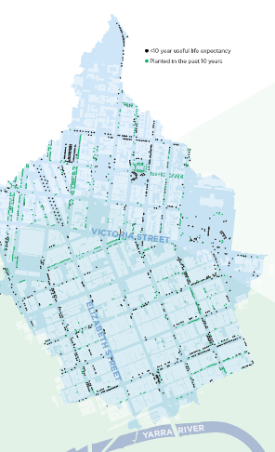
Caption: New trees and trees in decline, in the Elizabeth Street Catchment.

Integrated water cycle management in a city
The City of Melbourne practices integrated water cycle management. This is the coordinated management of all components of the water cycle including water consumption, rainwater, stormwater, wastewater and groundwater, to secure a range of benefits for the wider catchment.
Undertaking this integrated management in a city or urban water catchment presents very different challenges than managing catchments in more natural, less built environments.
Unsealed or permeable soil surfaces in a natural landscape allow water to infiltrate into soil slowly and be used by vegetation. In built urban environments such as Melbourne, there are large areas of sealed soil such as under roads and buildings where water is unable to penetrate, and quickly runs off into drains. During this process, water collects all forms of urban pollutants, including sediments, oil, nutrients (including nitrogen), metals, plastics and other rubbish, and then carries them into our rivers.
Urban soils also do not act the same as those in a natural ecosystem. Due to being sealed or covered over, urban soils can be compacted and lacking in nutrients and soil organisms. This prohibits soils from being able to capture and hold water, and also stops groundwater infiltration. Low soil water holding capacity and sealed surfaces mean less vegetation in the city which in turn contributes to a loss of biodiversity and an increase in the urban heat island effect.
This all accumulates to create a significant change in natural hydrological cycle. The aim of water management within an urban context is to restore the natural water cycle rhythm, slow water down and allow for groundwater infiltration and regeneration. The aim is also to allow evapotranspiration and subsequently, urban cooling to occur.
In Melbourne, the volume of stormwater runoff from our rainfall is greater than the amount we actually use from our dams. This volume of water is more than enough to provide both an alternative supply for non-drinking purposes and a healthy flow to our waterways and bays.
We need to value and use Melbourne’s rainfall to minimise water price increases, reduce urban flooding, to improve the health of waterways and bays and enhance liveability, self-sufficiency and amenity.
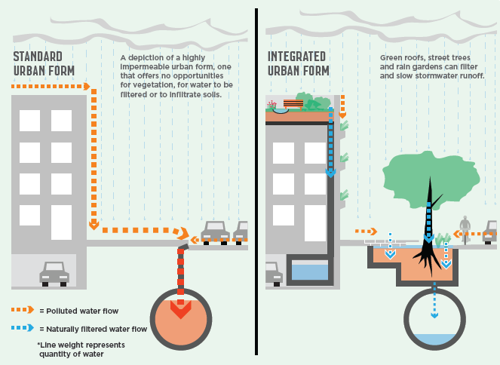
Caption: Integrated water cycle management transforms the urban landscape and results in less water entering the storm water drainage network during the peak of the storm run off.

Progress to date
Across the municipality of Melbourne, landholders, building owners and the City of Melbourne have implemented numerous innovative and successful interventions including using alternative water sources to irrigate parks and gardens. Examples are permeable pavements, stormwater harvesting tanks, blackwater recycling and raingarden tree pits.
Many of those undertaken within the Elizabeth Street Catchment during the past decade are included in the table below.
Location | System type | Storage size  (kilolitre) or equivalent | Catchment area (hectares) | Completion date | Alternative water source used (ML) | Storm-water flow reduction (ML) | Total Nitrogen Stormwater pollutant load reduction (kg) | Project owner
Lt Bourke St - Elizabeth to Queen | Raingarden tree pits | 0.56 | 0.083 | 2006 |  | 0.2 | 0.098 | City of Melbourne
Davison Place | Raingarden | 1.6 | 0.055 | 2006 |  | 0.2 | 0.46 | City of Melbourne
Lt Collins St - Spring to Exhibition | Raingarden tree pits | 1.04 | 0.223 | 2007 |  | 0.4 | 1.51 | City of Melbourne
Victoria St - Corner of Elizabeth | Infiltration Tree Pits | 2.88 | 0.15 | 2012 |  | 0.23 | 0.6 | City of Melbourne
Collins St (Eliz-Queen) permeable bluestone | Permeable Paving, infiltration and structural soil | 0.54 | 0.17 | 2013 |  | 0.787 | 1.9 | City of Melbourne
Queen Vic market  Queen St (Franklin – Therry Sts) | Underground tank, Toilet reuse | 600 | 1.43 | 2006 | 5.0 | 5.0 | 11.6 | City of Melbourne
CH2 Building  240 Lt Collins St | Sewer mining, water recycling | 30 | 0.1 | 2006 |  |  |  | City of Melbourne
60L Building  60 Leicester St Carlton | Rainwater &, Blackwater recycling | 20 |  | 2002 | 0.5 | 1 | 1.4 | Private
500 Bourke St | Rainwater, | 91 |  | 2009 | 36 | 36 | 1 | Private
Allan Gilbert Building | Rainwater tanks for toilet flushing | 300 |  |  | 10 | 10 | 1.2 | University of Melbourne
Faculty of Economics & Commerce Building, 198 Berkley St | Rainwater tanks, Blackwater recycled |  |  | 2010 | 32 | 10 | 1.2 | University of Melbourne
Urban workshop  50 Lonsdale St | Blackwater reuse, |  |  | 2006 | 0.5 |  | 1 | DHS
Southern Cross West Tower  111 Bourke St | Blackwater recycling |  |  | 2012 | 0.2 |  |  | Private
Royal Exhibition Building - Museum  Rathdowne St, Western forecourt | Rainwater tanks used for irrigation and toilets | 1500 | 1.9 | 2011 | 6.4 | 6.4 | 18.5 | Victorian Government (Museum)
200 Victoria street | Underground Rainwater tanks | 200 |  | 2010 | 4 | 4 | 1 | EPA
120-136 Collins St | Rainwater tanks used for garden | 8 |  | 1991 | 0.2 | 0.2 | 0.7 | Private

Case studies
The case studies below provide more detail on projects implemented in the Elizabeth Street Catchment to reduce flooding, increase open space, soil moisture and areas of unsealed soil and to improve vegetation quality.

Royal Exhibition Building and Melbourne Museum stormwater harvesting tanks – 2011
An underground tank was installed to store rainwater captured from the extensive roof of the Royal Exhibition Building, and from surrounding paved areas. The completed tank is 23m x 23m wide and 2.6m high. It has a storage capacity of 1.35 million litres. The system is expected to supply 6.4 million litres of alternative water for reuse in the toilets, fountains, lakes, and irrigation of the garden beds and trees, in accordance with Museum Victoria's commitment to sustainable management practices.
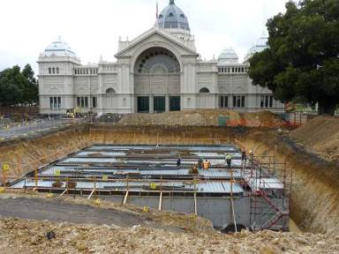

Queen Victoria Market stormwater harvesting tanks - 2006
Rainwater is piped, collected and stored in a 600,000 litre underground tank. This provides a new water source for the Queen Street public toilets and saves the Queen Victoria Market from using five million litres of drinking water annually. In addition, the decreased stormwater discharge from Queen Victoria Market has reduced pressure on nearby drainage infrastructure that has a history of flooding, and reduced the stormwater pollutant load in the Yarra River and Port Philip Bay.
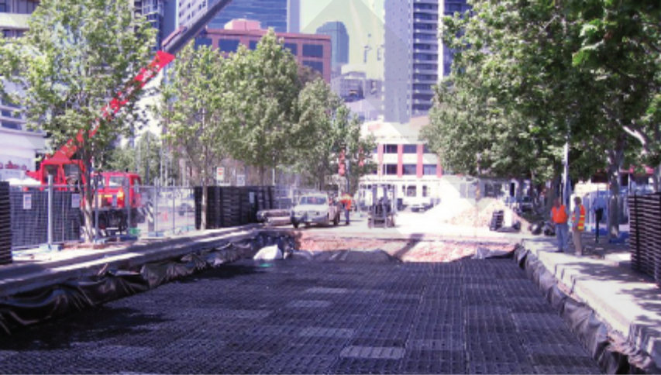
The University of Melbourne Economics Building blackwater recycling project - 2010
When constructing its Economics Building in Berkeley Street Carlton, the University of Melbourne included the installation of a blackwater recycling system. It is capable of treating 30,000 litres of sewerage per day. Being a student building, the main use of water is for toilet flushing. By using recycled water, it is expected that mains water use will be reduced by more than 80 per cent.
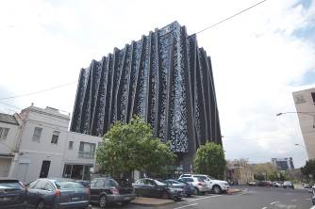

Little Bourke Street rain garden tree pits
In Little Bourke Street, the City of Melbourne installed the first of many raingarden tree pits to be utilised across greater Melbourne. Raingarden tree pits are designed so that stormwater is captured from the street gutter and directed to the base of the tree in the footpath. Sediment and litter is captured on top of the soil, while the tree roots and soil microorganisms remove any dissolved nutrients. The tree benefits from being watered naturally and excess moisture drains away via the underground drain. Any larger flows bypass the inlet grate to enter the standard drainage system. This intervention is only possible for new tree plantings because we can’t create a pit around an existing tree without harming the roots.
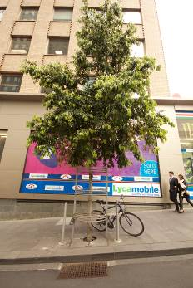

Collins Street permeable paving project
In this new intervention being piloted in Collins Street, the City of Melbourne laid a permeable strip of bluestone footpath next to the standard bluestone paving, which is laid on a highly impermeable 150mm thick concrete slab. The new permeable paving provides the existing trees with access to moisture from stormwater runoff. We are also using a similar intervention in asphalt footpaths and parking lanes where we utilise a “no-fines” asphalt mix. This allows water to flow through to the structural soil below where it is directly utilised by the trees, or infiltrates into the surrounding soil. The project is an example of ‘unsealing soil,’ as the underlying soil now has access to air and water.
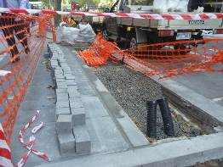

Targets in detail
Flooding
1:20 Average Recurrence Interval (ARI) (or equivalent) flow capacity of all council drains within the catchment.
This target will reduce damage caused by floods, but will not totally eliminate flooding. Floods are a normal part of the water cycle, and we will always have some level of flooding. Climate change modelling for Melbourne predicts heavy rain events will occur more often.
Average Recurrence Interval (ARI) is the predicted time between two similar types of flood events occurring at a particular place. For example, floods with a discharge as large as a 1:20 year ARI flood will occur on average once every 20 years and the much larger 1:100 event means it should only happen once in 100 years.
Our drains are designed to handle the more frequent flood events, of less intensity, generally to a 1:5 ARI. In the central city, this standard is being increased to cope with a 1:20 ARI event. But many of our drains are over 100 years old and are currently under the 1:20 ARI standard. This plan includes an analysis of the drainage network and areas for improvement.
Alternative water use
2018 targets
- 8% of all municipal water use sourced from alternative water sources
- 30% of all council water use sourced from alternative water sources
2030 targets

- 20% all municipal water use sourced from alternative water sources
- 50% of all council water use sourced from alternative water sources
Achieving these targets will require an increase in non-drinking water sources. This can include reusing rain or stormwater, or recycled wastewater - sewerage, blackwater or greywater. The capture, treatment and reuse of rainwater and stormwater have the added benefit of helping to reduce the impact of flooding. It also helps to improve the quality and reduce the quantity of stormwater running into our creeks and rivers. Storage can include smaller - 5,000-20,000 litre - rainwater tanks on household lots as well as larger stormwater harvesting from our drains and road network.
Recycling wastewater decreases flows in the sewers, reducing the need to upgrade sewer pipes and treatment plants in the future.
An analysis of the volumes of alternative water use required to meet these targets is included in this plan. This target is outlined in our Total Watermark – City as a Catchment strategy updated 2014.
Unsealed soil
40% of the Elizabeth Street Catchment’s soil surface is unsealed by 2030 (baseline year 2014).
Sealed soil refers to paving, roads and buildings covering the soil, preventing air and water from getting in. Unsealed or permeable soil includes soil that has no asphalt, concrete or paving on it. It can be bare earth or soil covered by grass or other vegetation. Permeable paving is an approximate of unsealed soil, as it allows water and air to permeate through paved surfaces, including road surfaces. Green roofs are one of the methods used to offset the effect of creating a sealed surface. Although water cannot reach the ground under a building, a new layer of soil is being provided on the rooftop that can hold some water.
This is an ambitious target when applied across both public and private land.
Water quality
2018 target
- 20% reduction in Total Nitrogen contributed to the waterways from the municipality of Melbourne’s catchment (baseline year 2000).
2030 target
- 30% reduction in Total Nitrogen contributed to the waterways from the municipality of Melbourne’s catchment (baseline year 2000).
Nitrogen is used as an indicator of pollutants in stormwater because it is one of the hardest pollutants to remove. Achieving the Total Nitrogen reduction target will also remove sediments, nutrients like phosphorus, heavy metals and litter.
Achieving the previous three targets will allow us to meet this target.
Open space
Increase the provision of open space in the Catchment
Increasing open space will increase the amount of unsealed soil or the permeability of the Catchment. This will allow more water to be absorbed, decreasing stormwater runoff. Open spaces can also serve to temporarily contain floodwaters in larger events. Plans to achieve this increase are outlined in the City of Melbourne’s Open Space Strategy and the City North Structure Plan.
Canopy cover
Increase canopy cover to 40% across the Catchment by 2040
This will mitigate urban heat by providing shade over roads, footpaths and buildings. The canopy also intercepts rainfall, thus mitigating runoff. The evapotranspiration of water as it moves through vegetation and evaporates off foliage aids in cooling during the summer months.
Achieving this target is outlined in the City of Melbourne’s Urban Forest Strategy and Carlton and Central City Urban Forest Precinct Plans.
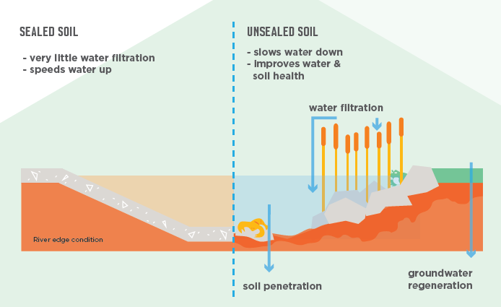
Caption: The difference between sealed and unsealed soil for water flow and permeability.

What’s needed?
In order to meet our targets, we needed to determine the current drainage capacity and flood extents, establish current levels of water use and measure the amount of sealed soil.

Drainage Capacity.
To achieve the 1:20 Average Recurrence Interval (ARI) flow capacity of all council drains within the catchment we needed to know the current capacity of the drains. This was assessed using geographic information system (GIS) data on pipes, pits and the LiDAR (Light Detection and Ranging) data from the catchment. We then modelled the catchment to determine what ARI event the drainage network could currently cope with. Where the capacity was under the 1:20 ARI level, we modelled the level of retention storages needed to take some of the flow and bring the capacity of the drain up to the 1:20 ARI level. Retention storages can be single or multiple tanks, ponds or other structures that start to fill when the drain is full of water. The results of this analysis are shown in the following figure.
The lengths of drains that are most undersized are displayed in red. We now need to analyse the GIS data against our site survey of the pipes and pits, to determine if the recommended pipe upgrades listed below are feasible. As part of the Action Plan we will develop neighbourhood plans for each sub-catchment detailing specific interventions including how retention storages can be implemented.
As shown, storages are most needed in the upper catchment areas. The storages can take various forms including traditional retention basins but also, depending on how they are designed and managed, can include rainwater tanks, stormwater harvesting systems, infiltration and permeable paving systems, raingardens and tree pits.
The total retention volume required throughout the catchment is 25.4 million litres. Based on previous cost figures and a 50:50 split of the retention between council and private, this volume of retention would require a $20.5 million investment by council and $12.7 million by private land owners.

Drainage capacity increase
Increasing the pipe sizes in two key locations will make a significant improvement to the conveyance of stormwater when the system is near capacity. These are Therry Street between Elizabeth Street and Victoria Street and Lonsdale Street between Swanston Street and Exhibition Street. Works in these locations are highly challenging due to the proximity of many other services, high traffic volumes on the roads and the existence of tram lines. A cost estimate, using 2015 rates, to conduct these works is $7million.
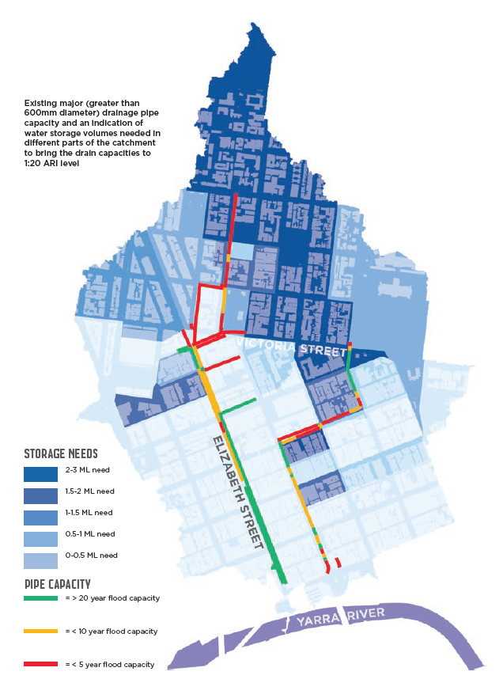
Caption: Existing major (greater than 600mm diameter) drainage pipe capacity and an indication of water storage volumes needed in different parts of the catchment to bring the drain capacities to 1:20 average recurrence interval level.

Water use
To set our alternative water use targets by 2018 and 2030, we needed to know how much water is currently consumed in the Catchment. City West Water has provided us with the following water usage data, including all private and public water use. The City of Melbourne (council) portion of this water is mainly used to irrigate open space, street trees and medians. It is estimated to be more than 41 million litres per year, depending on summer rainfall levels.
Year | Total annual volume (millions of litres) public and private water used
2011/12 | 7,230.6
2012/13 | 7,425.7
2013/14 | 7,600 (estimate only)

The table below outlines our municipal and council alternative water use targets and the volumes of water needed annually to achieve these targets:
Volume of water needed to meet alternative water use targets
2018 | 2030
Target: 8% of all municipal water use sourced from alternative water sources | Target: 20% all municipal water use sourced from alternative water sources
Volume of water needed for municipal use: 608 million litres (expected demand, based on 2013/14 use) | 1520 million litres (based on 2013/14 use)
Target: 30% of all council water use sourced from alternative water sources | Target: 50% of all council water use sourced from alternative water sources
Volume of water needed for council use: 12.25 million litres (expected demand, based on 2013/14 use) | Volume of water needed for council use: 20.5 million litres (expected demand, based on 2013/14 use)

Council alternative water requirements can be more than adequately met by utilising council drainage retention storages. These could supply 88 million litres of alternative water.
Achieving the municipal targets will be more challenging. Assuming the drainage retention storages are provided in both private and public land, and are used to provide alternative water source outside of flooding periods, an additional 1115 million litres per annum of alternative water will need to be sourced to achieve the 2030 target. This equates to requiring approximately two thousand two hundred and thirty (2230) 20,000 litre rainwater tanks. This number of tanks would require an investment of over $45 million. A better solution would be to provide access to a centralised alternative water network. The City of Melbourne will continue to work with the Victorian Government and water authorities to provide solutions at a lower cost for the community.

Sealed soil
The table below outlines the current level of sealed and unsealed surfaces/soil that exist in the Catchment. The areas are divided into council managed and private areas to more clearly define the works required.
Our target is that by 2030, more than 40 per cent of the Elizabeth Street Catchment’s soil surface is unsealed. In order to meet our target by 2030, we have proposed targets of 55 per cent and 30 per cent respectively for council managed and private areas.
These targets equate to an additional 306,955 square metres of council managed land being unsealed by 2030, and 380,780 square metres of private areas. For council, this will require a signification investment ($81 million) to convert roads to green open space and the conversation of footpaths, bike paths and parking lanes to permeable paving.
Current sealed and unsealed soil areas – 2014
 | City of Melbourne managed areas | Total area (m²) | Private areas | Total area (m²)
Sealed surfaces | Roads | 843,400 | Hard Surfaces | 299,600
 |  |  | Roofs | 1,404,600
Unsealed surfaces | Nature Strips | 78,400
 | Trees | 189,100 | Trees | 132,200
 | Vegetation | 81,200 | Vegetation | 54,200
 | Total | 1,192,100 | Total | 1,890,600
 | Unsealed soil | 29% | Unsealed soil | 10%
 | Sealed soil | 71% | Sealed soil | 90%

Total current percentage of sealed and unsealed soil
- 17% unsealed soil
- 83% sealed soil
To meet target by 2030
Whole catchment | 40% | 1,233,080 m²
City of Melbourne managed areas | 55% | 655,655 m²
Private areas | 30% | 567,180 m²

Water Quality
By achieving our alternative water use targets we will also achieve our water quality target.

Open space and canopy cover
A preliminary assessment of potentially available road space that could be converted to open space is approximately 60,000 square metres. This will provide new and enlarged open space in a catchment that is rapidly increasing in population. By installing permeable paving and renewing streetscapes through development, we will be able to meet our increased canopy cover target.
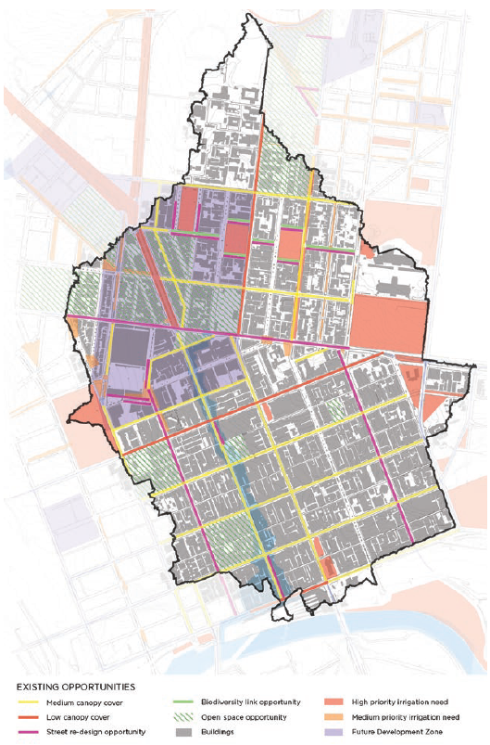
Caption: Opportunities to increase canopy cover and irrigate open space in the Elizabeth Street Catchment.

Key opportunities
To reach our targets and objectives it is necessary to implement a range of new projects. There are also numerous development projects in the pipeline, including the redevelopment of Queen Victoria Market. These works present opportunities to create more open space, increase soil moisture and the proportion of unsealed soil, improve the health of existing vegetation and reduce flooding.
The Catchment presents exciting possibilities for maximising open space and increasing the urban forest through planting trees and other vegetation. It has quite wide roads that will allow us to create new parks and medians or widen existing medians.
We have the ability to use new permeable asphalt and bluestone paving techniques when updating our roads and footpaths.
Through implementing the recommendations contained in the Urban Forest precinct plans for Carlton and the Central City, we can increase the permeability of the Catchment. We can increase the infiltration of stormwater by designing new or replacement tree planting in line with integrated water cycle management principles.
We are also looking to work with key landholders in the Catchment to reduce runoff when they are carrying out building or renovation works.
Our role involves investigating the effectiveness of our current planning tools in delivering the Plan’s targets and looking at whether improvements need to be made to strengthen these regulations and guidelines.
Our 2012 City North Structure Plan states that there will be more than 10,000 new people living in the Catchment by 2040, which means a rapid increase in development of new buildings and urban form. This development presents key opportunities to mitigate flooding by introducing retention storages, increase drainage capacity and use green roofs and streetscape renewal to unseal soil.
Green roofs
Green roofs and other green infrastructure can provide multiple benefits to the urban landscape. Such as water filtering, run-off delay, increased urban biodiversity and cooling the city. City of Melbourne recognises the importance of green roofs, as opposed to traditional standard roofing options. This recognition is reflected in the Growing Green Guide: A guide to green roofs, walls and facades in Melbourne and Victoria, Australia. www.growinggreenguide.org
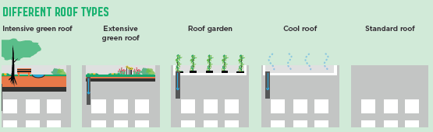
Caption: Different roof types.
Action Plan
The following actions have been developed through our stakeholder engagement They are a set of initiatives that will help us progress towards our target over the next 5 years, beginning 1 July 2015.
 | Strategic | Advocacy | Partnership | Capital
Year 1 | Develop neighbourhood plans for each sub-catchment detailing specific interventions. |  | Establish an Elizabeth Street Catchment Plan reference group | University Square renewal
 | Undertake intervention modelling for the whole catchment and sub-catchments |  | Renew the Melbourne Water Elizabeth Street Main Drain Flood Model | Investigate the expansion options for Lincoln and Argyle Squares
 |  |  | Develop a partnership approach with the major landholders in the catchment | Site survey of drainage upgrade sites
Design and build the Carlton Squares Flood Mitigation and Stormwater Harvesting Scheme
(Years 1-3)
 |  |  |  | Investigate the opportunity to expand the Council House 2 sewer mine to a neighbourhood scale recycled water scheme (Years 1-5)
Year 2 | Analysis the potential impact of the Melbourne Planning Scheme’s Energy, Water and Waste Efficiency (clause 22.19) and Stormwater management (clause 22.23). | Develop a wider community engagement program | Investigate the Elizabeth St and Flinders St nexus of the Elizabeth St Main Drain and overland flow path to determine the possible options for conveying the overland flow past/through the Flinders Street Railway Station | Enlarge one of the key drainage bottlenecks
 | Investigate the alternative water main for the municipality and how it will affect the Elizabeth Street Catchment |  |  | Pelham Street median and open space
 |  |  |  | Enlargement of Lincoln square
Years 3-5 |  | Investigate a flood mitigation/on-site retention offset scheme. |  | Enlarge the remaining 3 drainage bottlenecks
 |  | Investigate an on-site retention/flow attenuation rebate scheme for the upper catchment areas |  | Queen Victoria Market renewal
 |  |  |  | Enlargement of Argyle Square
 |  |  |  | Expansion of La Trobe and Exhibition Street Reserve

Climate Commission, The Critical Decade 2013: Climate change science, risks and responses.
CSIRO, Southern Slopes Cluster Report, Climate Change in Australia Projections for Australia’s Natural Resource Management Regions, 2015
Victoria State Emergency Service, Annual Report 2007–2008

